Q1.) program to search for a particular character in a string

2Q.) program to convert minutes to seconds?

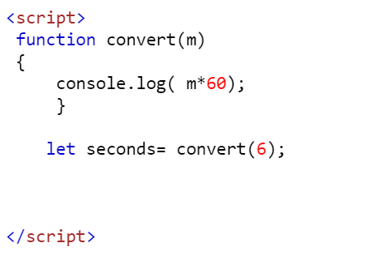

Output= 360 seconds

3Q.) program to search for a element in an array of strings?

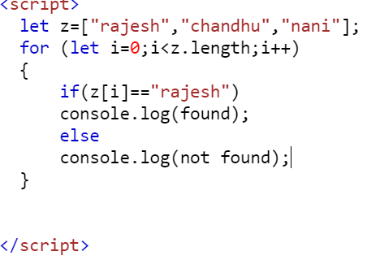

Output = found

4Q.) programs to display only elements containing ‘a’ in them from a array?

Output=rajesh,chandhu, nani

5Q. print an array in a reverse order?

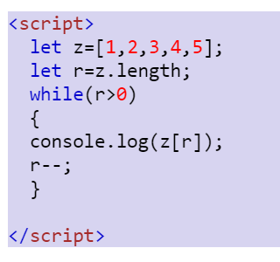

Output= 5,4,3,2,1